MODEL QUESTION PAPER
B.E. Production Engineering
V Semester

PR 333 METROLOGY AND COMPUTER AIDED INSPECTION

Time : 3 Hours Max Marks : 100 marks

Answer ALL Questions

PART A (10 x 2 = 20 Marks)

- What is the difference between a line standard and an end standard. Give some examples.
- How precision is measured?
- How sine bar is used for setting a job at an angle in a milling machine.
- What is an electronic level?
- What is the principle of calibration of slip gauges using gauge block interferometer.
- How the radius of a template, approximately 200mm, is measured using Toolmakers microscope.
- How the fidncial point in a pitch measuring machine works?
- How the gear profile is checked?
- What is a laser micrometer?
- What are the advantages of using solid state cameras in machine visim.

Part B (5 x 16 = 80 marks)

11. Explain how a hex mi spherical component shown in fig.1. below is measured for its dimensional and form accuracy using a co-ordinate measuring machine. Clearly indicate (i) how the component is clamped
(ii) what are the initial set up required in CMM
(iii) What type of probe is used
(iv) What measurement strategy is used.
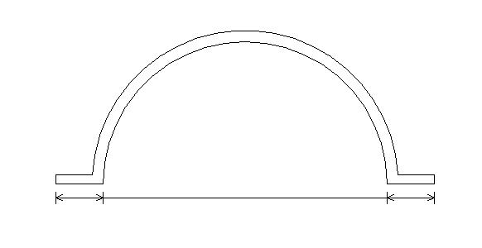
150mm
2mm thick
120
20
20
Fig.1
12.a)i) What precautions are taken for calibrating a measuring instrument.

ii) Explain how an outside micrometer is calibrated for progressive and periodic error.
OR
12.b)i) How errors in measurement system are classified?

ii) Explain with neat sketched some common errors. How these errors are minimized or eliminated?

13.a)i) What is the principle of working of an electrical comparator?

ii) How an electrical comparator is most suited for checking multi dimensional components ‘on line’. Explain with neat sketches.
OR
13.b)i) What factors are considered in the design of limit gauges?

ii) Design required limit gauges for checking the component pair 30 H₈d₉.

14.a)i) How straightness error is measured?

ii) Explain how flatness of a 1000 x 1000 mm cast iron surface plate is checked using either an autocollimator or a spirit level.
OR
14.b)i) What is the best wire size required for checking the effective diameter of a M 20 x 1.5 mm thread?

ii) What is a rolling gear tester? How various elements of a gear are obtained from the profile of the gear tester?

15.a)i) What types of probes are used in a co-ordinate measuring machine? Give specific application of each probe.

ii) Explain how flank wear of a single point turning tool is measured ‘in process’ using Laser.
OR

15.b)i) What are the applications of machine vision in metrology.

ii) Explain various methods used for identification of job in machine vision.
-----

